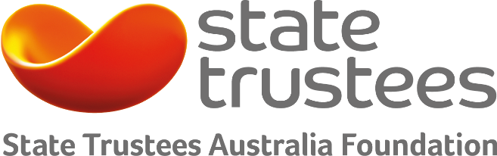
Elder abuse
prevention and response
2016 Grants Program

State Trustees Australia Foundation
The Foundation was established in 1994 as a public charitable trust administered by State Trustees. Funded by donations and bequests from generous donors, the Foundation has distributed more than $12 million in the last 20 years.

Elder abuse prevention and response funding priorities

Awareness building activities
- to build awareness of the issue and provide people with information about what constitutes elder abuse and how to prevent and address it
Education and skill development programs
- to help older people to understand, assert and protect their rights
Social participation programs
- to help older people to stay socially connected
Information services to help older people to access independent advice prior to making decisions about housing and financial matters and to access information about power of attorney and guardianship options
- to help older people to manage their financial affairs and plan for and have choice over who will manage their affairs if they lose capacity
Capacity building and training for community health workers and carers
- to help them to identify and respond to (prospective) issues

Projects that help Victorians will be given preference.

Why is the Foundation funding elder abuse prevention and response?
State Trustees Australia Foundation has a particular focus on helping those disadvantaged by ageing, disability and mental health. The Foundation aims to promote social inclusion, and provide support for individuals to live independently and build and maintain physical, emotional and spiritual wellbeing and resilience, as well as reduce the incidence of adverse health issues that can limit their ability to live well.

What are the objectives of the elder abuse program?
To support older Australians to participate fully in economic, social and family life by supporting people to remain independent, active and socially connected as they age and exercise choice and control in how they engage with the service systems that support them.

How much funding is available for a project?
The program will fund grants ranging from $50,000-$100,000.

Funding category
- Elder abuse prevention and response

Funding amount
- Up to $100,000

Timeframes
- Closes 19 Aug 2016

Eligibility
- Item 1 DGR organisations which are charitable at law

How will my project be assessed?
The initial call for applications will be a simple expression of interest form. Shortlisted organisations will then be asked to come for a face-to-face meeting with the assessment panel.

Who is eligible?
Australian eligible entities providing direct community support or activities are eligible to apply. Note, an eligible entity is endorsed as Item 1 Deductible Gift Recipient (DGR) and is charitable at law.

What are the timeframes?
Applications can be submitted until Friday 19 August 2016. Shortlisted applicants would meet with the assessment panel in September 2016. Outcomes will be announced in December 2016.

How do I apply?
We use SmartyGrants – an online application form. Remember to save each page when entering information. We recommend reading these tips on how to use SmartyGrants: Help Guide for Applicants.

Already familiar with SmartyGrants? Then login to our application form: https://statetrustees.smartygrants.com.au/2016elderabuse

Who do I contact for more information?
Contact us on (03) 9667-6740 or send us an email if you would like more information or to discuss your project: charitable@stl.com.au

