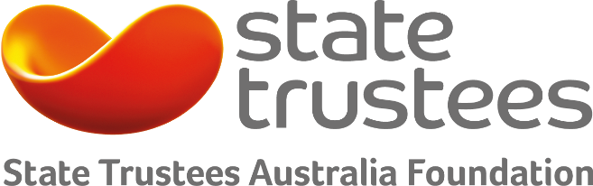

John burge trust fund
2018 Grants Program Guidelines

Funding amount
- Grants from $20,000 to $50,000

Timeframes
- Closes 9 April 2018

Eligibility
- Charities

The John Burge Trust Fund was established by the late John Burge to assist people with tuberculosis.

Granting under the Trust Fund has recently been reviewed. Below are the revised guidelines for applicants.

How much funding is available for a project?
The program provides individual grants ranging from $20,000 - $50,000.

Who is eligible?
Only charities may apply. We ask for one application per organisation.

Can the project take place outside Australia?
Yes. Projects can be undertaken within Australia or overseas.

How will applications be assessed?
All applications will be assessed and ranked against each other. Assessment criteria will include:
- how well an application fits within the purposes of the trust
- the suitability and experience of an organisation to undertake tuberculosis interventions
- the impact of the project, such as the total number of individuals who are expected to be helped.

What are the timeframes?
Applications can be submitted until 9 April 2018. Successful applicants must sign and return their conditions of award before 15 June 2018.

How do I apply?
We use SmartyGrants – an online application form. Remember to save each page when entering information. We recommend reading these tips on how to use SmartyGrants: Help Guide for Applicants.

Already familiar with SmartyGrants? Then login to our application form: https://statetrustees.smartygrants.com.au/2018JohnBurgeTrustFund

What are the purposes of the trust?
The Trust Fund will grant funding:

- for the purpose of aiding and helping those who are suffering, or have suffered from, tuberculosis and who by reason of the disease are disabled

- to provide funds to implement programs for identifying and treating those persons who are at a higher risk than other members of the population of having or contracting tuberculosis

- to provide funds to implement educational programs to inform health workers about the prevention, recognition, and treatment of tuberculosis

- to provide medication for, and supervision of the use of medication by, members of groups who are at a high risk of having or contracting tuberculosis

Who do I contact?
Applicants are encouraged to contact State Trustees to discuss their applications.

Contact Erin Dolan (03) 9667-2845 or erin.dolan@statetrustees.com.au.

