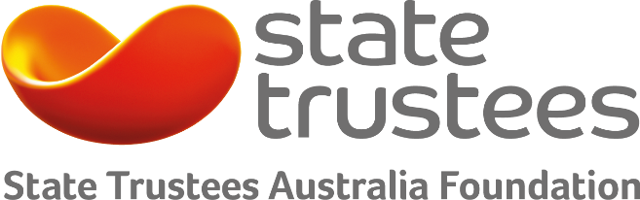

Grassroots
2018 Grants Program
Ageing, disability and mental health

State Trustees Australia Foundation
The Foundation was established in 1994 as a public charitable trust administered by State Trustees. Funded by donations and bequests from generous donors, the Foundation has distributed more than $27 million to charities that make a difference in the community.

State Trustees Australia Foundation has a focus on helping those disadvantaged by ageing, disability and mental health.

What are the objectives of the Grassroots program?
Applications must help those disadvantaged by ageing, disability and mental health through social inclusion and social participation. This includes:

- Community awareness, education and engagement programs to promote social inclusion and address direct and indirect discrimination
- Programs to support social participation, to reduce social isolation and improve personal wellbeing and quality of life
- Programs to support carers to look after themselves and those that they care for

We have a preference for projects that:

- provide an integrated solution to social inclusion and social participation
- have a lasting impact
- fund smaller community-led organisations
- are used for pilots, one-offs, new and emerging ideas
- are Victorian based

Who is eligible to apply?
An eligible entity is endorsed as item 1 Deductible Gift Recipient (DGR) and registered as a charity with the Australian Charities and Not-for-profits Commission.

What are the timeframes?
Applications can be submitted until Wednesday 27 June 2018. Outcomes will be announced in November 2018.

How much funding is available for a project?
The program provides individual grants up to $20,000.

Examples of projects we’ve funded
Take a look at what we funded last year: 2017 Grassroots Grants

How do I apply?
We use SmartyGrants – an online application form. Remember to save each page when entering information. We recommend reading these tips on how to use SmartyGrants: Help Guide for Applicants.

Already familiar with SmartyGrants? Then login to our application form: https://statetrustees.smartygrants.com.au/2018grassroots

Who do I contact for more information?
Contact us on (03) 9667-2845 or send us an email if you would like more information or to discuss your project: charitable@stl.com.au

