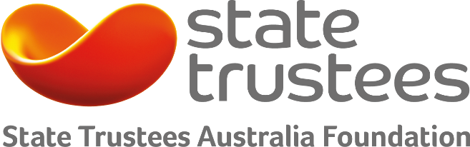
Elder abuse prevention and response
2018 program guidelines

State Trustees Australia Foundation
The Foundation was established in 1994 as a public charitable trust administered by State Trustees. Through the generosity of donations and bequests from donors, the Foundation has distributed more than $27 million to charities that make a difference in the community.

State Trustees Australia Foundation has a focus on helping those disadvantaged by ageing, disability and mental health. This commitment extends to funding elder abuse prevention and response programs and raising awareness about elder abuse generally.

2018 Elder abuse prevention and response grants program
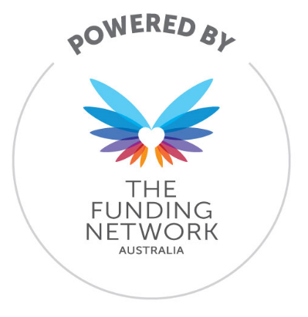
To mark World Elder Abuse Awareness Day 2018, the Foundation will be working with The Funding Network to help grassroots organisations working in the fields of positive ageing, elder abuse prevention and elder abuse response to host a live crowdfunding event in June 2018.

At the event, a representative from three charities will have six minutes to pitch their organisation and their project. Invited guests will then pledge donations to each organisation. More information about The Funding Network can be found here: https://www.thefundingnetwork.com.au/

Who can submit an application?
Organisations must meet the following eligibility criteria:

1/ Eligible charity
Organisations must confirm that they are endorsed as item 1 Deductible Gift Recipient (DGR) and registered as a charity with the Australian Charities and Not-for-profits Commission.

2/ Less than $2 million annual revenue
Organisations must have an annual average income below $2 million over the last three years. If your income is just over this amount due to extenuating circumstances, please contact us to discuss.
3/ Victorian
Organisations must be based in Victoria and able to travel to Melbourne for pitch coaching and the event (see below for important dates).

How much funding is available for a project?
The event is expected to raise approximately $25,000 for each organisation. Applicants should request funding for project costs up to this amount specifically related to their work in the elder abuse sector.

What are the important dates?
- Applications can be submitted until Thursday 5 April 2018
- Successful applicants will attend a pitch coaching workshop in Melbourne on 22 May 2018
- The fundraising event will be held in Melbourne on Thursday 14 June 2018

How do I apply?
We use SmartyGrants – an online application form. Remember to save each page when entering information. We recommend reading these tips on how to use SmartyGrants: Help Guide for Applicants.

Already familiar with SmartyGrants? Then login to our application form: https://statetrustees.smartygrants.com.au/2018elderabusepreventionresponse

What are the priorities of the program?
It is expected that applications will fit into one of the following priority activities to reduce elder abuse:

Awareness building activities
- to build awareness of the issue and provide people with information about what constitutes elder abuse and how to prevent and address it
Education and skill development programs
- to help older people to understand, assert and protect their rights
Social participation programs
- to help older people to stay socially connected
Information services
- to help older people to access independent advice prior to making decisions about housing and financial matters and
- to access information about power of attorney and guardianship options to help older people to manage their financial affairs and plan for and have choice over who will manage their affairs if they lose capacity
Capacity building and training for community health workers and carers
- to help them to identify and respond to (prospective) issues

Who do I contact?
Applicants are encouraged to contact and/or meet with State Trustees Australia Foundation to discuss their applications.

Contact Erin Dolan (03) 9667-2845 or erin.dolan@statetrustees.com.au

