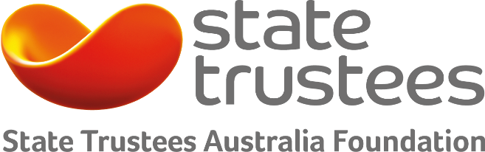
Funding category
- Ageing Well
- Disability
- Mental health and emotional wellbeing

Funding amount
- Grants up to $10,000

Timeframes
- Closes 28 July 2017

Eligibility
- Item 1 DGR organisations and ACNC charity registration

Grassroots
2017 Grants Program
Ageing, disability and mental health

State Trustees Australia Foundation
The Foundation was established in 1994 as a public charitable trust administered by State Trustees. Funded by donations and bequests from generous donors, the Foundation has distributed more than $27 million to charities that make a difference in the community.

State Trustees Australia Foundation has a particular focus on helping those disadvantaged by ageing, disability and mental health.

How much funding is available for a project?
The program provides individual grants up to $10,000.

Examples of projects we’ve funded
Take a look at what we funded last year: 2016 Grassroots Grants

Who is eligible?
An eligible entity is endorsed as item 1 Deductible Gift Recipient (DGR) and registered as a charity with the Australian Charities and Not-for-profits Commission.

What are the timeframes?
Applications can be submitted until Friday 28 July 2017. Outcomes will be announced in November 2017.

How do I apply?
We use SmartyGrants – an online application form. Remember to save each page when entering information. We recommend reading these tips on how to use SmartyGrants: Help Guide for Applicants.

Already familiar with SmartyGrants? Then login to our application form: https://statetrustees.smartygrants.com.au/2017grassroots

What are the objectives of the program?
Applications must help those disadvantaged by ageing, disability and mental health through:

1. Social Inclusion
- Community awareness, education and engagement programs to promote social inclusion and address direct and indirect discrimination.
- Elder abuse prevention and response programs.

2. Social and Emotional Wellbeing and Health Promotion
- Holistic health & wellbeing promotion programs.

3. Self-management/ Self-care
- Programs to support people to live independently and support self-management and self-care.
- Financial literacy, planning and management programs.
- Programs to promote financial / income security.

4. Social Participation
- Programs to support social participation, to reduce social isolation and improve personal wellbeing and quality of life.

5. Carer Support
- Programs to support carers to look after themselves and those that they care for.

We have a preference for projects that help Victorians or are Victorian based.

Who do I contact for more information?
Contact us on (03) 9667-2845 or send us an email if you would like more information or to discuss your project: charitable@stl.com.au

